**Software Requirement Specification Document (SRS)**

**Hostel Management System**

**Created By: Om Vijay Mundlik 2255**

**Guided By: Mrs. Sanchita Tikam Mam**

**Version 1.1 Date: 29/03/2024**

**Table of Contents:**

1. **Introduction 1**
2. Purpose
3. Intended Audience
4. Scope
5. Definition
6. Reference
7. **Overall Description 4**
8. User Interface
9. System Interface
10. Constraint, Assumption, Dependency
11. User Characteristics & Hardware Characteristics
12. **System Feature & Requirements 4**
13. Functional Requirements
14. Used Interface
15. External Interface Required
16. Non-Functional Requirements
17. **System Design 4**
18. Use Case Diagram
19. Entity Relationship Diagram
20. Class Diagram
21. Data Flow Diagram
22. Sequence Diagram
23. Decision Table
24. **Software Testing 4**
25. Test Case
26. System Size Estimation (LOC, Function Point)
27. System Cost Estimation (COCOMO)
28. **Delivery and Approval**
29. **Introduction**
30. Purpose

The Purpose of this document is to provide you a detailed review of Requirements of Hostel Management System. This SRS will be helpful for complete understanding of How Hostel Management Software will be. The clear understanding of the system and its functionality will allow for the correct software to be developed for the end user and will be used for the development of the future stages of the project. This SRS will provide the foundation of the project. From this SRS, the Hostel Management System can be designed, constructed and finally tested. The Project team will use the SRS to fully understand the expectations of the Hostel Management System to construct the appropriate software.

1. Intended Audience

The Intended Audience of the Hostel Management System Software are Following

1. Hostel Administrator
2. Student who wants to live in Hostel
3. Hostel Security Guard
4. Hostel Mess Administrator
5. Scope

The scope of the Hostel Management System includes Purpose of the software, Features of the software,

Benefits, Goals of the Software & Objective Etc. I mentioned some of it below.

* **Purpose of the Software**

1. To Reduce the Effort of Administrator
2. To Digitalize Hostel Management System
3. To Enable Paperless work in Hostel
4. To Enable Computerized Rollcall & In-out Entry
5. To Establish Direct and Transparent Communication between Hostellers & Administrator.

* **Features of the Software**

1. Digital Registration and Application Process for Hostel
2. Online Student Selection Notification
3. 24/7 Guidelines and Support
4. Digital Overview of Hostel (all rules, etc.)
5. Digital Roll Call and In-out Entries
6. Regular Stipend-Related Updates
7. Online Hostel Mess Entry, Food Review, and Timetable
8. Raise a Request/Complaint
9. Live Review of Available Seats in Hostel

* **Benefits of Software**

1. Improved Data Handling
2. Data Security & Backup
3. Transparent Communication
4. Reduced Efforts
5. Definition

Admin – The Hostel Warden

Mess Admin – The Mess Administrator

Stipend- The Fund given to Student

1. Reference

SRS Template Pdf Source: -[**www.processimpact.com**](http://www.processimpact.com)

1. **Overall Description**
2. User Interface

The User Interface (UI) of the software is the most important & Interactive of Part of Software. The UI of the software will be simple and easy to use. As the intended Audience are different of the UI must be friendly to all the audience. In this software we used simple components that make it user friendly.

The UI Components used are Following:

1. Button
2. Textbox
3. Radio Button
4. Labels
5. Date Picker
6. Combo box
7. Search Box
8. Drop Box for Files
9. Label
10. System Interface

System Interface of the Hostel Management System Can be get understand by using the following Use Case Diagram.

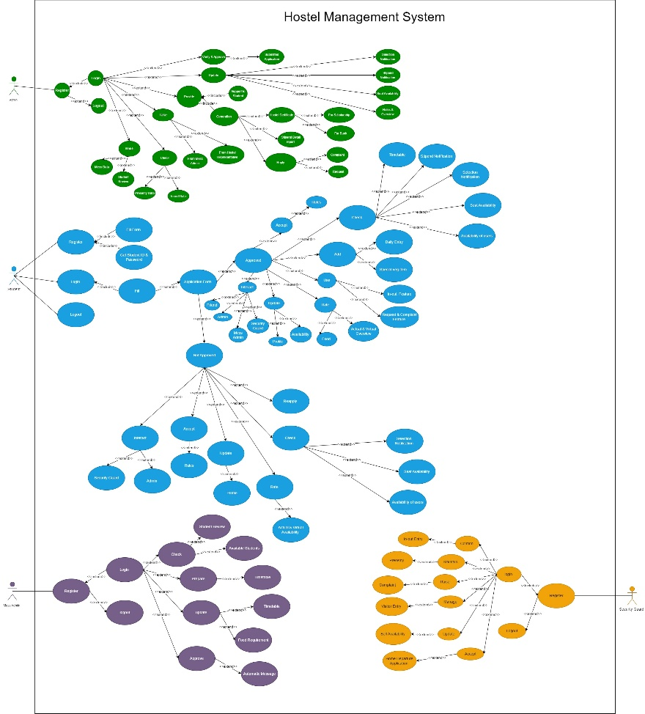

‘

1.0 Hostel Management system Use case Diagram

1. Constraint, Assumption, Dependency
2. Constraints
3. The student who is applying for the hostel must accept the rules
4. The documents uploaded by student must be in proper format and original.
5. The student must have bank account in bank of India
6. Deny the student to access the feature of in_out Entry after 7 pm and in special condition use emergency out option.
7. The student must have add their name in mess entry. If forgot then send notification.
8. Student can take benefit of seats according their caste reservation ..they can’t take benefit of seats allocated for other caste reservation.
9. All users must update their availability in hostel.
10. Student must give their food review after having meal/dinner/breakfast.
11. The order given by vegetarian student on Wednesday/Saturday must be automatically get forwarded to food providers.
12. Assumptions
13. Students have access to a device with internet connectivity.
14. The software integrates with a student information system or has a mechanism for user authentication.
15. Students have access to the software or an email address for notification.
16. The software has a built-in knowledge base or FAQ section.
17. An alternative support channel exists (e.g., phone hotline, email) for complex issues.
18. The software has a mechanism for student identification
19. Dependencies
20. Secure database to store student information and application data.
21. Email notification system or in-app notification module.
22. Content management system for maintaining guidelines and FAQs
23. Hardware for student identification (e.g., card reader, QR code scanner).
24. User Characteristics & Hardware Characteristics
25. User Characteristics

* **Admin:**

1. Application Verification & Approve
2. Provide Update regarding Selection & Stipend
3. Provide Support to Students
4. Update Vacant Seats Availability
5. Updating Rules & Overview of Hostel
6. Take Review from Hostel Mess Admin & Hostel Representative
7. Check Presenty & In-out Data of Student
8. Keep watch on Student Review & Mess Data
9. Replying Student Complaint & Request
10. Update Self Availability in Hostel

* **Student:**

1. Self-Registration
2. Fill Application Form for Hostel
3. Check Notification Related Selection & Stipend
4. Check Seat Availability
5. Interact with friends
6. Verify Actual & Virtual Overview provided by the app & Rate According to it
7. Review Food & Rate it
8. Accept Rules of Hostel
9. Create & Update Profile
10. Check Timetable
11. Use In-out Feature
12. Raise a request & complaint
13. Add Daily Entry for Meal from App

* **Mess Admin:**

1. Check student Review and Prepare Timetable and Update it.
2. Update Food Requirements as per student
3. See Available Students from Mess Data
4. Automatic Message to Food Providers

* **Security Guard:**

1. In-out Entry Confirmation
2. Maintain Presenty
3. Manage Visitor Entry
4. Update Self Availability in Hostel
5. Raise Complaint Against Student
6. Accept Student Home Departure Application
7. Hardware Characteristics
8. Mobile Phone
9. Processor (CPU): - snapdragon
10. Memory (RAM): - minimum 4gb ram
11. Storage: - 120 mb
12. Display: - Any display
13. Connectivity: - WIFI, Ethernet
14. Camera: - 8 megapixel minimum
15. Operating System: - Android
16. Laptop/Computer
17. Processor (CPU): - Intel i3-i5 above Processor
18. Memory (RAM): - minimum 4gb ram
19. Storage: - N/A
20. Display: - 1920*1080 resolution
21. Connectivity: - WIFI, Ethernet
22. Operating System: - Windows 7 above
23. **System Feature & Requirements**
24. Functional Requirements
25. Digital Registration and Application Process for Hostel
26. Online Student Selection Notification
27. 24/7 Guidelines and Support
28. Digital Overview of Hostel (all rules, etc.)
29. Digital Roll Call and In-out Entries
30. Regular Stipend-Related Updates
31. Online Hostel Mess Entry, Food Review, and Timetable
32. Raise a Request/Complaint
33. Live Review of Available Seats in Hostel
34. Used Interface
35. Internal Interface
36. **Dashboard:** The dashboard of the software provides an overview of the hostel management system. It includes links to various modules and important information such as the number of available seats, pending requests, and notifications.
37. **Digital Registration and Application Process for Hostel:** This module allows students to apply for hostel online. Students can fill out an application form, upload necessary documents, and submit the application. The system should provide real-time updates on the status of the application.
38. **Online Student Selection Notification:** Once the Warden review the applications, they can use this module to notify selected students. The system should send notifications via email or SMS and provide details about You are selected and come for confirmation.
39. **24/7 Guidelines and Support:** This module provides students with access to hostel guidelines, rules, and regulations. It also includes contact information for hostel staff and support services available 24/7. It also shows availability of staff in hostel
40. **Digital Overview of Hostel (all rules, etc.):** This module provides detailed information about the hostel, including room view, facilities, rules, and regulations. It should also include a virtual tour of the hostel.
41. **Digital Roll Call and In-out Entries:** This module allows the security guard to keep track of student’s attendance and movements. Students can check in and out using a digital system, and the system should generate reports for hostel Warden.
42. **Regular Stipend-Related Updates:** This module provides updates on stipend payments, including payment status, payment history, and upcoming payments. Students can also submit requests for stipend-related issues.
43. **Online Hostel Mess Entry, Food Review, and Timetable:** This module allows students to view the hostel mess menu, submit feedback on the food quality, and view the mess timetable. It also includes adding name facility for meal confirmation.
44. **Raise a Request/Complaint:** This module allows students to raise requests or complaints related to hostel facilities, maintenance, or other issues. Students can track the status of their requests and receive updates from hostel authorities.
45. **Live Review of Available Seats in Hostel:** This module provides real-time information on the availability of hostel seats. Students can check the number of available seats and apply for hostel accordingly.
46. **Admin Panel:** This module is accessible only to hostel warden. It provides access to all the modules mentioned above, along with additional features such as managing student records, generating reports, and setting up system configurations.
47. **Security and Access Control:** The interface should include security features such as user authentication, id-based access control, and data encryption to ensure the confidentiality and integrity of student information.
48. External Interface Required
49. API
50. **Google Maps API**: Google Maps API technology helps by providing real time location of hostel in Software.as well as it shows routes to reach hostel for convenience of student.
51. **Graphql API:** It will help to reduce the unnecessary use of bandwidth on network. It provides specific data that we need by avoiding the unnecessary data sharing.
52. Hardware Interface

It requires following Hardware

1. Processor (CPU)
2. Memory (RAM)
3. Storage
4. Display
5. Battery
6. Connectivity
7. Sensors
8. Camera
9. Operating System
10. Graphics Processing Unit (GPU) (*estimated)
11. Non-Functional Requirements
12. Security Requirements
13. Every person needs to be authenticated.
14. Only authorized user has the access of data.
15. Admin must have the control of the user.
16. Safety Requirements

The database may get crashed at any certain time due to virus or operating system failure. Therefore, it is required to take the database Backup.

1. Efficiency Requirements
2. Use minimal system resources like CPU, RAM, and battery.
3. Load quickly and respond promptly to user actions.
4. Optimize data usage to reduce strain on the device and network.
5. Portability Requirements

Software must be able to use of different device like Mobile and Desktop

1. **System Diagram**
2. Use Case Diagram

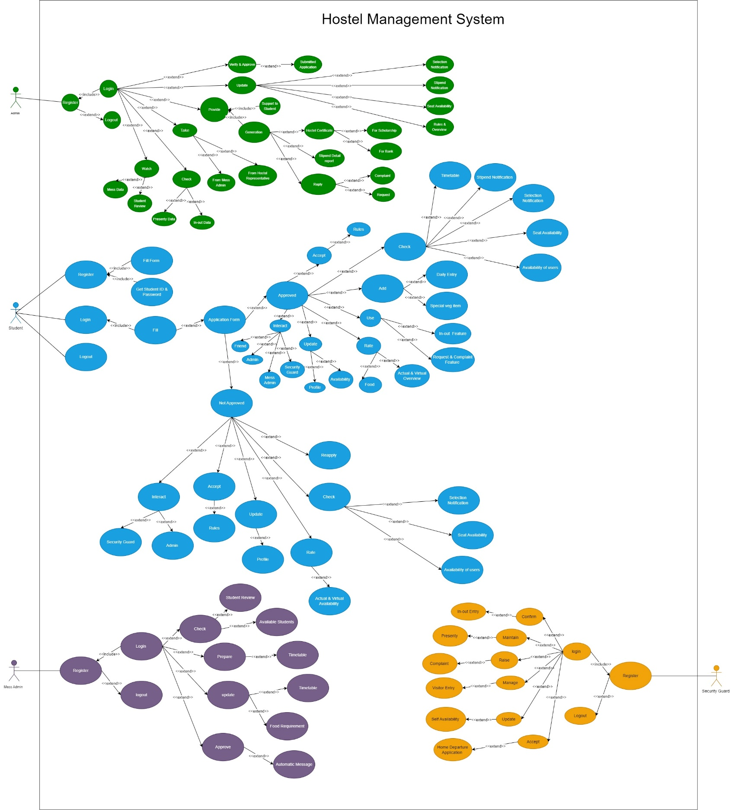The Use Case Diagram of Hostel Management System tells us the Actor in HMS with its Cases.

1. Entity Relationship Diagram (ERD)

Er diagram displays entities, their attributes, and the relationships between. It helps in planning and understanding how information is organized in a database system.

Address

Mobile_No

Reason

Time_of_Arrival

Time_of_Departure

Standard

Student_id

Today_Date

Sr. No

Refers

Pass

Warden

Handled By

Sr. No

In_out_Passcode

Account_No

Joining_date

Education

Family_income

Student_Birthdatee

Caste_Category

Student_Name

Student_id

Student_Register_Data

Sr. No

Daily_in_out

Admin

1. 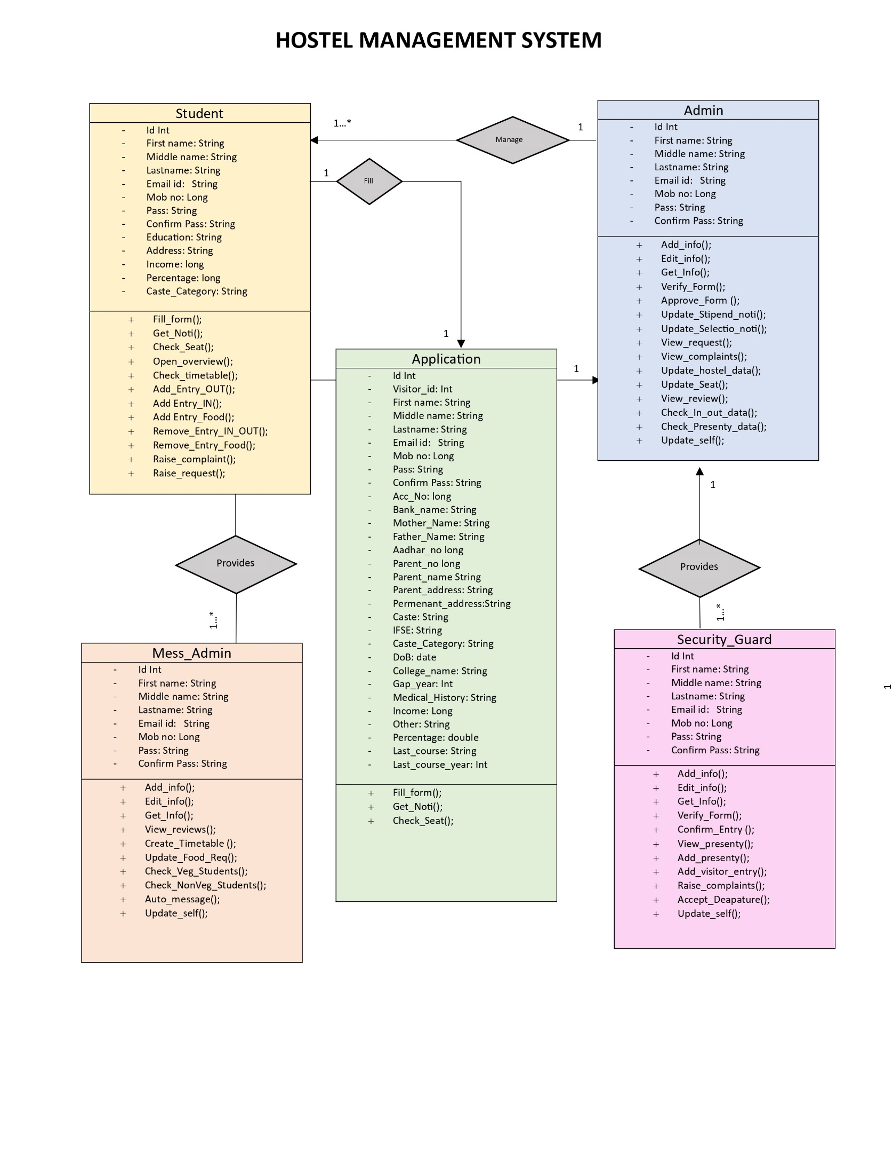Class Diagram (Detailed)
2. Data Flow Diagram







1. Sequence Diagram

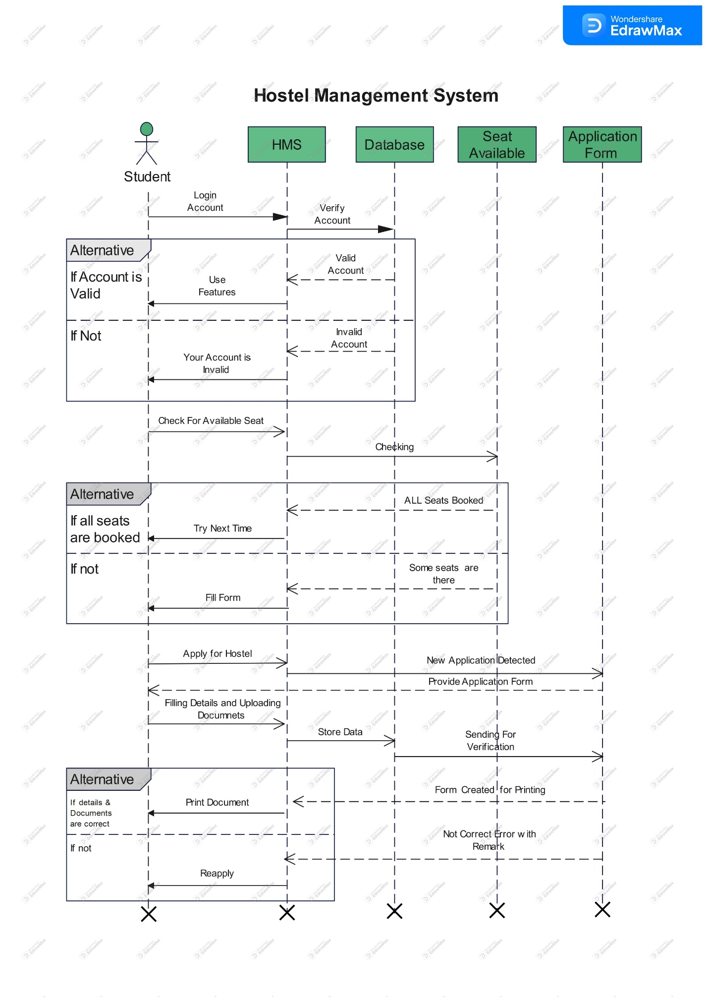

|  |  |  |  |  |  |
| --- | --- | --- | --- | --- | --- |
| **Id** | **Action/Condition** | **T1** | **T2** | **T3** | **T4** |
| 1 | Username | T | T | F | F |
| 2 | Password | T | F | T | F |
| 3 | In-out Enty Confirmation | USABLE |  |  |  |
| 4 | login Successful | EXECUTE |  |  |  |
| 5 | Wrong Credentials. |  | EXECUTE | EXECUTE | EXECUTE |
| 6 | Maintain Presenty | USABLE |  |  |  |
| 7 | Manage Visitor Entry | USABLE |  |  |  |
| 8 | Update Self-Availability | USABLE |  |  |  |
| 9 | Raise Complaint | USABLE |  |  |  |
| 10 | Accept Departure letter | USABLE |  |  |  |

1. Decision Table
2. Decision Table for Security Guard Module: -
3. Decision Table for Mess Admin Module: -

|  |  |  |  |  |  |
| --- | --- | --- | --- | --- | --- |
| **Id** | **Action/Condition** | **T1** | **T2** | **T3** | **T4** |
| 1 | Username | T | T | F | F |
| 2 | Password | T | F | T | F |
| 3 | login Successful | EXECUTE |  |  |  |
| 4 | Wrong Credentials. |  | EXECUTE | EXECUTE | EXECUTE |
| 5 | Check Review and Prepare Timetable | USABLE |  |  |  |
| 6 | Update Food Requirements as per student | USABLE |  |  |  |
| 7 | See Available Students from Mess Data | USABLE |  |  |  |
| 8 | Automatic Message to Food Providers | USABLE |  |  |  |

1. Decision Table for Admin Module: -

|  |  |  |  |  |  |
| --- | --- | --- | --- | --- | --- |
| **Id** | **Action/Condition** | **T1** | **T2** | **T3** | **T4** |
| 1 | Username | T | T | F | F |
| 2 | Password | T | F | T | F |
| 3 | login Successful | EXECUTE |  |  |  |
| 4 | Wrong Credentials. |  | EXECUTE | EXECUTE | EXECUTE |
| 5 | Application Verification & Approve | USABLE |  |  |  |
| 6 | Provide Update Selection & Stipend | USABLE |  |  |  |
| 7 | Provide Support to Students | USABLE |  |  |  |
| 8 | Update Vacant Seats Availability | USABLE |  |  |  |
| 9 | Updating Rules & Overview of Hostel | USABLE |  |  |  |
| 10 | Take Review from Hostel Mess Admin & Hostel Representative | USABLE |  |  |  |
| 11 | Check Presenty & In-out Data of Student | USABLE |  |  |  |
| 12 | Keep watch on Student Review & Mess Data | USABLE |  |  |  |
| 13 | Replying Student Complaint & Request | USABLE |  |  |  |
| 14 | Update Self Availability in Hostel | USABLE |  |  |  |

1. Decision Table for Student Module: -

|  |  |  |  |  |  |  |  |  |  |
| --- | --- | --- | --- | --- | --- | --- | --- | --- | --- |
| **Id** | **Action/Condition** | **T1** | **T2** | **T3** | **T4** | **T5** | **T6** | **T7** | **T8** |
| 1 | Username | T | T | T | T | F | F | F | F |
| 2 | Password | T | T | F | F | T | T | F | F |
| 3 | login Successful | EXECUTE | EXECUTE |  |  |  |  |  |  |
| 4 | Wrong Credentials. |  |  | EXECUTE | EXECUTE | EXECUTE | EXECUTE | EXECUTE | EXECUTE |
| 5 | Fill Application Form for Hostel | USABLE | USABLE |  |  |  |  |  |  |
| 6 | Form Approved | T | F | - | - | - | - | - | - |
| 7 | Check Notification Related Selection | USABLE | USABLE |  |  |  |  |  |  |
| 8 | Check Notification Related Stipend | USABLE |  |  |  |  |  |  |  |
| 8 | Check Seat Availability | USABLE | USABLE |  |  |  |  |  |  |
| 9 | Interact with friends | USABLE |  |  |  |  |  |  |  |
| 10 | Verify Actual & Virtual Overview provided by the app & Rate According to it | USABLE | USABLE |  |  |  |  |  |  |
| 11 | Review Food & Rate it | USABLE |  |  |  |  |  |  |  |
| 12 | Accept Rules of Hostel | USABLE | USABLE |  |  |  |  |  |  |
| 13 | Create & Update Profile | USABLE |  |  |  |  |  |  |  |
| 14 | Check Timetable | USABLE |  |  |  |  |  |  |  |
| 15 | Use In-out Feature | USABLE |  |  |  |  |  |  |  |
| 16 | Raise a request & complaint | USABLE |  |  |  |  |  |  |  |
| 17 | Add Daily Entry for Meal from App | USABLE |  |  |  |  |  |  |  |

1. **Software Testing**
2. Test Case 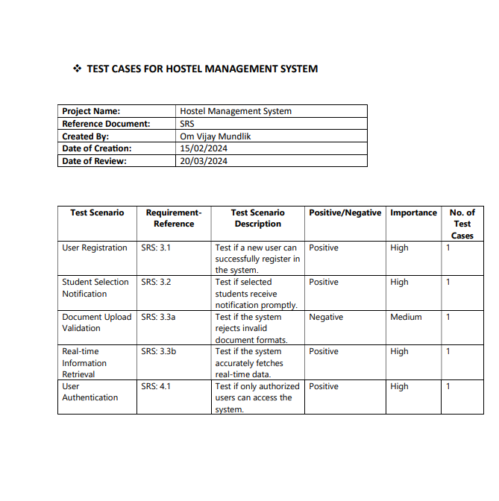
3. System Size Estimation (LOC, Function Point)
4. Line of Code

Total Line: 1200 lines

LOC: - 1000

1. Functional Point
2. External Input: - 80
3. External Output: -90
4. Internal Logical Files: - 95
5. External Logical Files: -40
6. 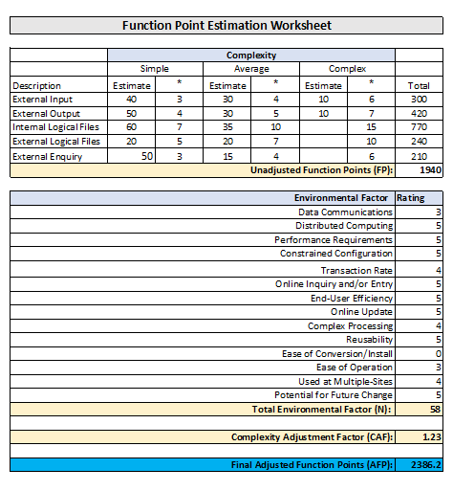External Enquiry: - 65

Unadjusted Function Points (FP)= **1940**

Total Environmental Factor (N)= **58**

Complexity Adjustment Factor (CAF)= 0.65+(0.01*N) = **1.23**

Final Adjusted Function Points (AFP)= FP*CAF =**2386.2**

1. System Cost Estimation (COCOMO)

Our Software LOC is less than 50k that’s why we use organic mode for Cocomo analysis.

In Organic Mode

a =2.4

b=1.05

c= 2.5

d=0.38

KLOC= 1

1. **Effort** = a(KLOC)^b = 2.4(1) ^1.05 = **2.4 persons-months**
2. **Development Time** = c(effort)^d = 2.5(2.4) ^0.38 = **3.277928 months**
3. **Average Staff Size=** Effort/ Development Time= **1 Person**
4. **Productivity** = KLOC/Effort =1/2.4= **0.42 kloc/person**

**************************************END************************************